Spring Trillium 10”x10” Art Quilt
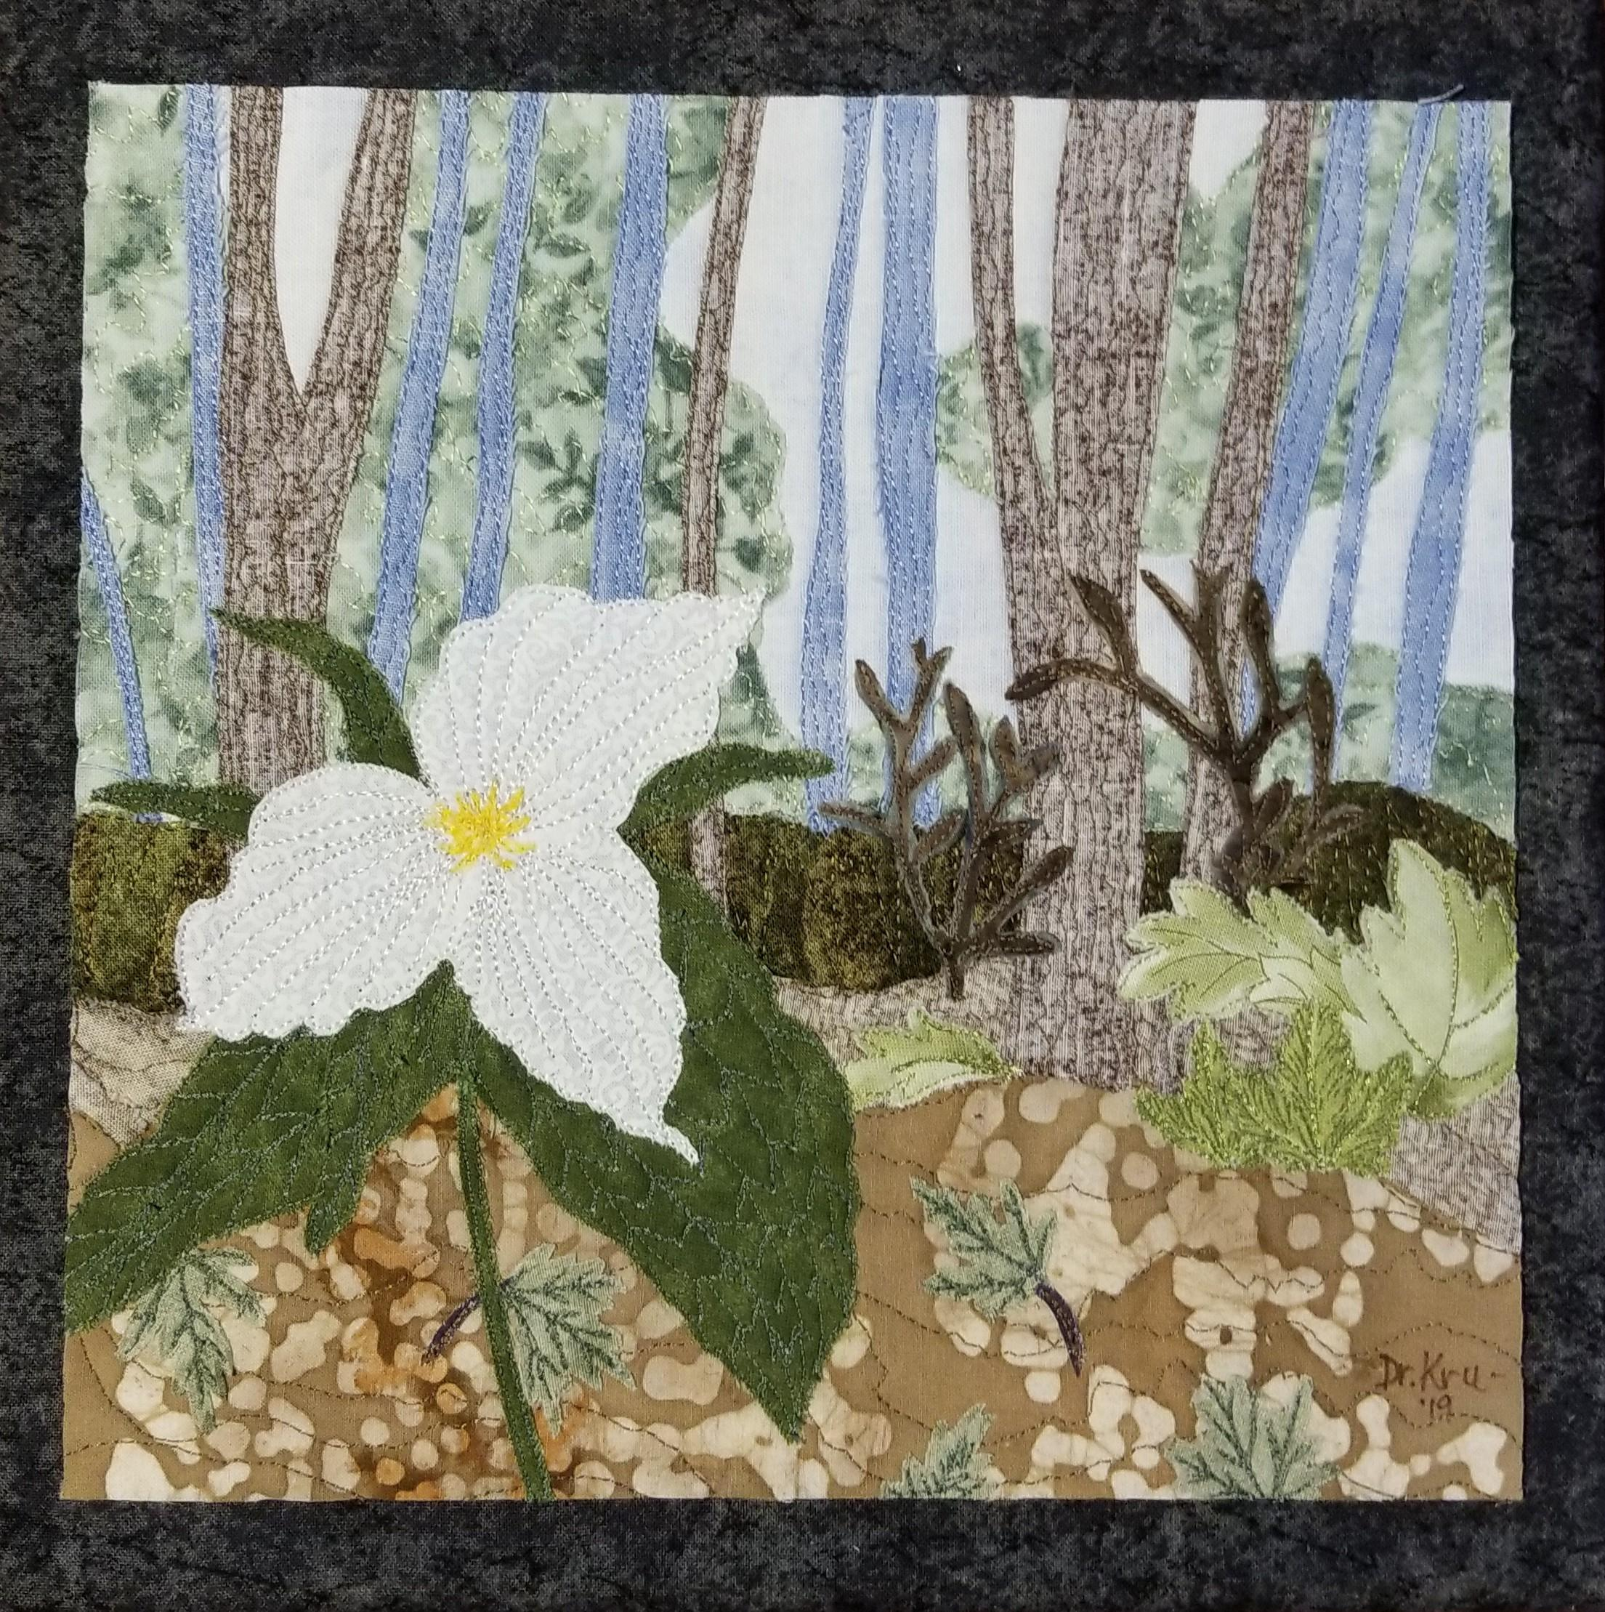
Class: Spring Trillium 10”x10” Art Quilt
Cost: Class $30- Supplies Kit $40.
Day 1: Learn the art of collage landscaping.
You will amaze yourself at how easy it is to create a simple fabric landscape of a
one of our favorite spring flowers nestled in a woodland setting.
Prepare to have fun!
Date: _______________
Location:

Time: (e.g.: 9:30-4:00)

Supply List:
Provided -
- Fabrics; sky, trees, light tan and green ground cover, flower, and greenery
- Wonder Under (pre-applied to all fabrics)
- 9” x 9” batting and backing
- 10” x 10” stretched canvas art frame
- 12½” x 12½” black fabric to cover art frame
- Parchment paper for ironing
- Irons and boards
Need to Bring -
- Sewing machine (I use open toe foot)
- Large glue stick; e.g., Craft Bond; Extra Strength
- Tacky glue
- Scissors – small and sharp for fussy cutting
- Scissors – for paper cutting
- Mat and rotary cutter (I use 28mm)
- Tweezers
- Erasable marker; e.g., Pilot Ball Frixion)
- Sewing gloves (optional)
- Thread
  - several shades of green; e.g., moss, olive, and mint
  - chocolate brown
  - medium tan
  - ight blue or gray
  - yellow for flower center
  - white

Dr. Susan Kruszynski – lives in Muskegon, Michigan, and is an award-winning art quilt designer, teacher, author, and gallery artist. Feeding her artistic nature, Susan, at age 8, started experimenting with fabrics to produce colorful creations. She began landscape fiber art design with collage art quilts in 2014. A native of Michigan, her works, that range in sizes from 3”x5” to 40”x60”, are often inspired by the trees and woodlands along the Lake Michigan shoreline.

- Susan currently divides her time between creating original collaged art quilt designs,
teaching art quilting, marketing this fiber art in shows and galleries, running her Quilting Fabrics in Time business, and only just recently retired as a literacy specialist from Muskegon Community College. Susan uses her 40+ years of K-College level teaching experiences and a PhD in Education to teach this art through in-class experiences in and around the state of Michigan, through on-line instruction, and with art quilt books from Fox-Chapel Publishing.
- Grand Rapids ArtPrize Nine 2017 (TOP 25), Reaching Upward ; J.Gardella’s Tavern on 11 Ionia
- Michigan Education Association (MEA) Art Acquisitions Purchase Exhibition, Kruszin' Thru the Seasons in 2018 and Teal Trees in 2019 (JURORS’ CHOICE AWARD and PURCHASE AWARDS); 1216 Kendale, Lansing
- Grand Haven Lighthouse Quilt Guild Show, 1st PLACE, Teal Trees in 2018 and Resilience #1 in 2019

Dr. Susan Kruszynski

Landscape Art Quilter

1265 Anna Road • Muskegon, MI 49445

Phone • 231.329.0201
Email • quiltingfabricsintime@gmail.com
Website • www.quiltingfabricsintime.com
Facebook • www.facebook.com/Quilting-fabrics-in-Time

